Estimating and Determining the Area of a Circle
Understands the relationships between radius, diameter, and area of a circle  I can cut the circle into equal sections and rearrange them into a rectangle. Half the circumference,  or πr, is the length and r is the width.  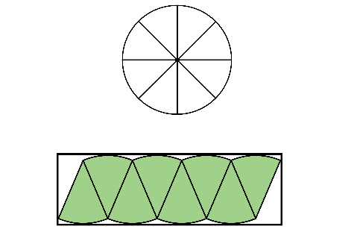 | Calculates the area of a circle, given its radius  What is the area of a circle with radius of 2 cm?  I used the area formula for a circle.  3.14 × 2² = 12.56  The area is 12.56 cm². | Calculates the area of a circle, given its diameter  What is the area of a circle with diameter of 6 cm?  I found the radius first and then the area.  6 ÷ 2 = 3  The radius is 3 cm.  3.14 × 3² = 28.26  The area is 28.26 cm². | Uses circle area formula to solve problems  Determine the area of a pizza with  a circumference of 94.2 cm.  I found the diameter first, then the radius, and finally the area.  d = C ÷ π = 94.2 ÷ 3.14  = 30  The diameter is 30 cm.  30 ÷ 2 = 15  The radius is 15 cm.  A = πr² = 3.14 × 15²  = 706.5  The area is 706.5 cm².
Observations/Documentation

