Determining the Area of Parallelograms
Explains the relationships between the area of a rectangle and a parallelogram  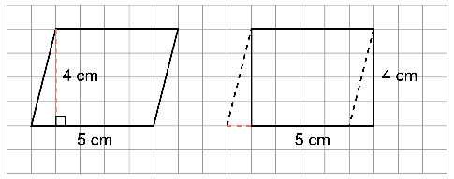  I cut a triangle from end of the parallelogram and moved it to the other end.  The area of the parallelogram was rearranged to form a rectangle, and no area was lost. So, the area of a parallelogram is the same as the area of a rectangle, 20 cm².  A = b × h | Determines the area of a parallelogram using the area formula.  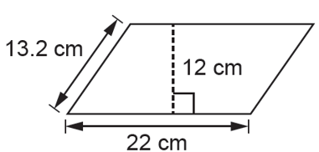  A = bh  A = 22 × 12  A = 264  The are of the parallelogram  is 264 cm². | Uses parallelogram area formula to determine a missing measure  What is the base of a parallelogram with area of 36 cm² and height of  6 cm?  A = bh  36 = b × 6  $\frac{36}{6}$ = b  b = 6  The base of the parallelogram  is 6 cm. | Flexibly solves problems involving the area of parallelograms.  How many of the smaller parallelograms would fit in the  larger parallelogram?  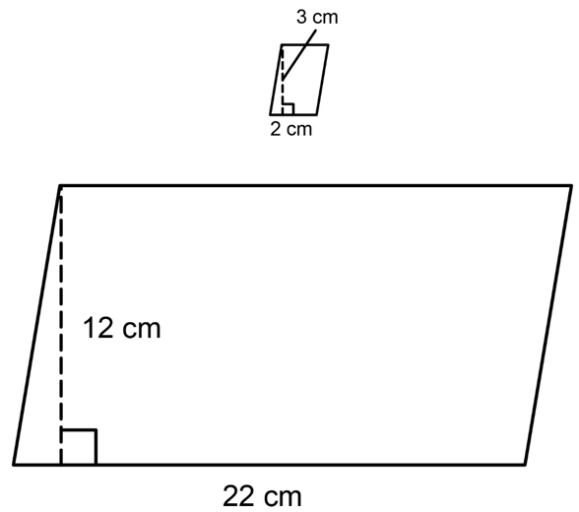  Area of smaller parallelogram:  A = 2 cm × 3 cm = 6 cm²  Area of larger parallelogram:  A = 22 cm × 12 cm = 264 cm²  264 ÷ 6 = 44; 44 smaller parallelograms would fit in the larger parallelogram.
Observations/Documentation

