Determining the Area of Triangles
Explains the relationships between the area of a rectangle and a triangle.  I drew a diagonal of the rectangle and divided the rectangle in two equal triangles.  Area rectangle = 50 cm²  Area triangle = 25 cm²  So, the area of a triangle is one-half the area of a rectangle.  A = b × h ÷ 2  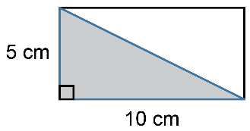 | Determines the area of a triangle using the area formula.  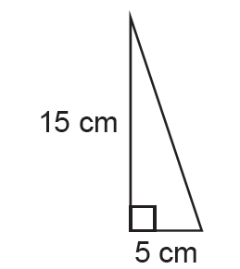  A = $\frac{1}{2}$bh  A = $\frac{1}{2}$ × 5 × 15  A = 37.5  The triangle has an area  of 37.5 cm². | Uses triangle area formula to determine a missing measure.  What is the base of a triangle with area of 36 cm² and height of 6 cm?  I used the area formula for a triangle.  A = $\frac{1}{2}$bh  36 = $\frac{1}{2}$ × b × 6  36 = 3 × b  $\frac{36}{3}$ = b  b = 12  The base of the triangle is 12 cm. | Flexibly solves problems involving the area of triangles.  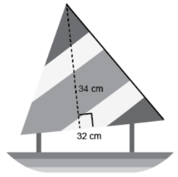  What is the area of the sail on the toy boat?  “The sail is a triangle with base  32 cm and height 34 cm.  A = $\frac{1}{2}$bh  A = $\frac{1}{2}$ × 32 × 34  A = 544  The area of the sail is 544 cm².”
Observations/Documentation

