Comparing Linear Patterns
Represents linear patterns in different forms    “I can represent this linear pattern with a table of values, graph, or pattern rule. The pattern rule for this pattern is Start at 1 and add 2 each time.” | Uses an expression that represents a linear pattern to complete a table of values  Pattern B: 2x + 2  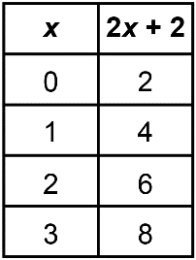  “I substituted each value of x into the expression to get the value of the expression, or the y-value.” | Uses constant rate and initial value to match graphs and pattern rules  Which graph represents 2x and which represents 2x + 4?  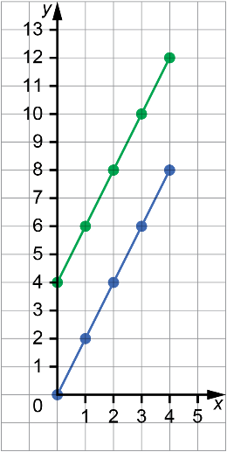  “I know the graph of 2x will begin at (0, 0) and the graph of 2x + 4 will begin at (0, 4). For both, every time you move right 1 you move up 2. The blue line represents 2x and the green line represents 2x + 4.” | Compares linear patterns by graphing them  Pattern A  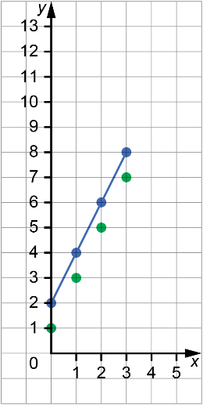  Pattern B: 2x + 2  “I graphed both patterns.  They have different initial values but the same constant rate, 2. Pattern A is a series of points, the points in Pattern B can be joined with a line.”
Observations/Documentation

