Representing Patterns
Represents a pattern by constructing a table of values and drawing a graph    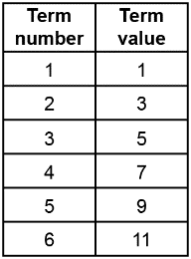  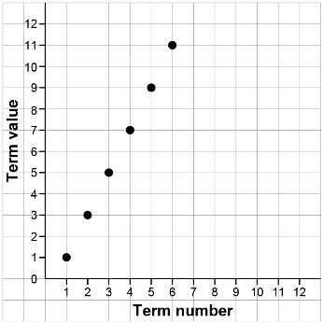 | Describes the pattern rule in relation to the term number orally and in written form for an increasing pattern  For this pattern, I can determine the number of tiles in any term by multiplying the term number by 2, then subtracting 1. | Determines whether a pattern is linear and explains how they know  For my pattern, every time the term number increases by 1, the term value increases by 2. This means the relationship is linear. When I look at the graph, all the points lie along a line. | Uses the relationship between term numbers and term values to solve problems  To determine the number of tiles in a particular term, I multiply the term number by 2, then subtract 1. So, Term 8 will have 2 × 8 – 1 = 15 tiles.
Observations/Documentation

