Subtracting Integers
Models subtracting a positive integer from a positive integer  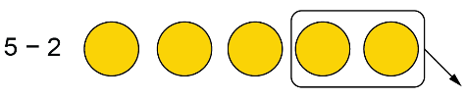  “5 – 2 = 3” | Subtracts a negative integer from a positive integer using the “add a zero pair” strategy    “I can’t remove two negative counters from five positive counters because there aren’t any negative counters. I need to add the zero pair +2 and –2. Now I can remove two negative counters.  So, 5 – (–2) = 7”. | Subtracts a negative integer from a negative integer using models  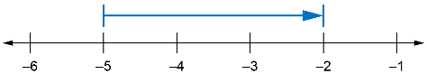  “–5 – (–3) is the same as adding  3 to –5, so the arrow starts at –5  and moves 3 units to the right.” | Subtracts two integers symbolically  –3 – (–5) = –3 + 5  = 2  “Both numbers are negative, but the magnitude of the number being subtracted is greater, so the difference is positive.”
Observations/Documentation

