Adding Integers
Adds two integers with like signs using two-sided counters    –3 + (–2) = –5  “The sum of two negative integers  is negative.” | Explains that the sum of opposite integers equals zero  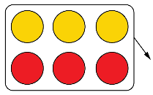  –3 + (+3) = 0  “Adding an integer and its opposite gives 0.” | Adds integers with opposite signs using counters and zero pairs or number lines  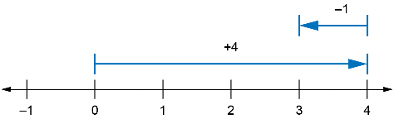  “Adding a negative number is the same as subtracting its opposite,  so I’ll move left (in the negative direction) to add –1.” | Adds two integers symbolically  “To add –6 + 2, I think 6 – 2 = 4  and 6 > 2, so the answer is –4.”
Observations/Documentation

