Representing Integers
Plots integers on a number line and then compares them using symbols  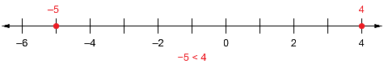  “–5 is less than 4 because it is farther left on the number line.” | Uses number lines to locate opposite integers  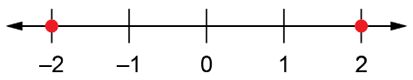  “2 and –2 are each the same distance from 0.” | Uses two-sided counters and zero pairs to represent an integer in more than one way    “This model shows +3 because  2 + (–2) = 0, and 3 + 0 = 3.” | Uses integers to represent real-life situations  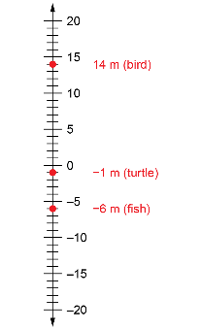  “The animals are above and below the surface of the lake, so 0 m is the level of the surface.”
Observations/Documentation

