Exploring Theoretical and Experimental Probability
Identifies the experimental probability of an outcome for two independent events  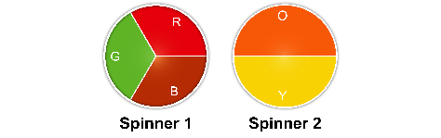  The results for 8 trials:  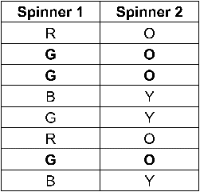  The outcome, green, orange, occurred 3 times. So,  the experimental probability of green, orange is:  $\frac{3}{8}$= 0.375  = 37.5% | Identifies the theoretical probability of an outcome for two independent events  Sample space:  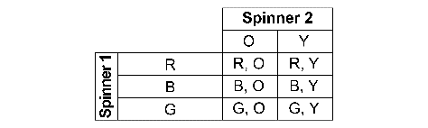  For green, orange, there is 1 favourable outcome and 6 possible outcomes.  So, the theoretical probability of green, orange is:  $\frac{1}{6}$= 0.1666…  ≈ 17% | Compares the theoretical and experimental probabilities for a probability experiment  The results for 10 trials.  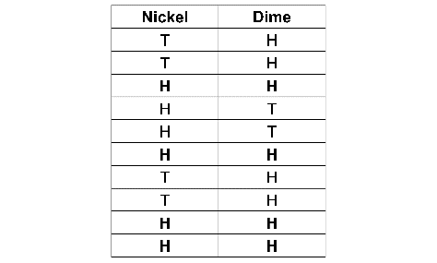  Sample space:    Experimental probability of 2 heads  is: $\frac{4}{10}$= 0.4 = 40%  Theoretical probability of 2 heads is:  $\frac{1}{4}$= 0.25 = 25%  The experimental probability is greater than the theoretical probability. | Understands how experimental and theoretical probabilities may be related if many trials are conducted  For 100s of trials of an experiment, the experimental probability of an outcome may approach its theoretical probability.
Observations/Documentation

