Identifying and Representing Sample Spaces
Determines the sample space for a single event  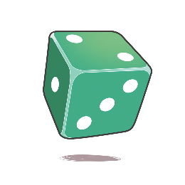  The sample space for rolling a die is:  1, 2, 3, 4, 5, 6 | Understands that one event does not influence another event    Tossing the first coin does not affect the outcome of tossing the second coin. | Distinguishes all unique outcomes when using identical objects  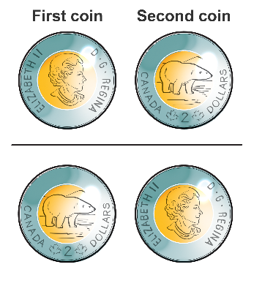  H, T is different from T, H even though the coins are identical. | Determines the sample space for two independent events  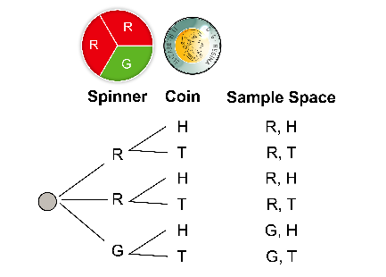
Observations/Documentation

